**GoComet Assignment**

**Test Cases**

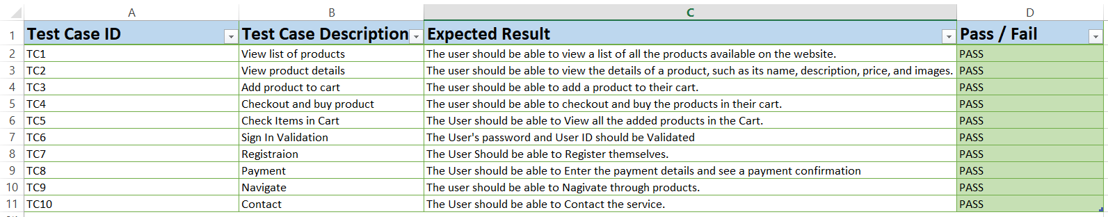

**BUGS AND IMPROVEMENT**

**Bug 1:** The product images are not aligned properly and some of them are cropped or distorted. This makes the website look unprofessional and reduces the user’s trust.

**Suggestion 1:** Use a consistent size and aspect ratio for all product images and ensure they are displayed correctly on different screen sizes and resolutions.

**Bug 2:** The contact information at the bottom of the page is not valid. The address is incomplete, the phone number is missing a digit, and the email address is not clickable. This makes it hard for the user to reach out to the website owner or report any issues.

**Suggestion 2**: Provide accurate and complete contact information and make the email address a hyperlink that opens the user’s default email client.

**Bug 3**: The website does not have a clear privacy policy or terms and conditions. This may violate some laws or regulations and expose the website owner to legal risks. It also makes the user unsure about how their personal data is collected, used, or shared by the website.

**Suggestion 3**: Create a privacy policy and terms and conditions page that comply with the relevant laws and regulations and link them from the footer of the website. Explain clearly what data is collected, why, how, and with whom it is shared, and how the user can opt out or request deletion of their data.

**Bug 4**: The website does not have a secure connection (HTTPS) and does not use encryption or authentication for the payment process. This puts the user’s sensitive information, such as credit card details, at risk of being intercepted or stolen by hackers or malicious third parties.

**Suggestion 4**: Implement HTTPS and use a trusted payment gateway or service that provides encryption and authentication for the payment process. Display a security badge or logo on the website to assure the user that their information is safe and secure.

**Bug 5**: The Website does not have a credit Card Validation as even characters can be entered too which can lead to a lot of payment issues

**Suggestion 5**: Implement a way so that only numbers can be entered and set the maximum number limit.

**Bug 6:** The product list page does not show the quantity of each product in stock and the number of the specific product added to the cart.

**Suggestion 6**: This could be improved by adding a "Quantity" column to the product list table.

**Bug 7**: The product details page does not show the shipping cost of the product

**Suggestion 7**: This could be improved by adding a "Shipping Cost" section to the product details page.

**Bug 8**: The checkout process does not allow the user to review their order before completing the purchase.

**Suggestion 8**: This could be improved by adding a "Review Order" page to the checkout process.